**Project Report Template**

**A CRM APPLICATION FOR SCHOOLS / COLLEGES**

**1 Introduction**

* 1. **Overview**

The way educational institutuions manager their interaction and communications with important groups like students, parents, alumni and other employees is crucial to their success. It is difficult job to manage educational institutions. On the one hand,organsing information and making it accessible requires strong data management skills. On the other side, it also necessitates nonstop, continuous functioning that is optimised and seamless. The salesforce CRM software assists educational institutions in streamlining administration because it is packed with several capabilities.

**1.2 Purpose**

Salesforce CRM is a multi-functional, cloud-baed education management system that was created for schools, colleges, and institutions. It assists users in controlling every part of their business, including admission and price collection, course scheduling, control over student credit points, and curriculum. The CRM software assists educational institutions in streamlining administration because it is packed with several capabilities.

**2 Problem Definition & Design Thinking**

The project aim is to prrovide real time knowledge for all the students have the basic knowledge of Salesforce and real time project. This have help those professionals are in cross technology & want switch to salesforce.

Design Thinking is part of the broader project-based learning educational model.

**2.1 Empathy Map:**

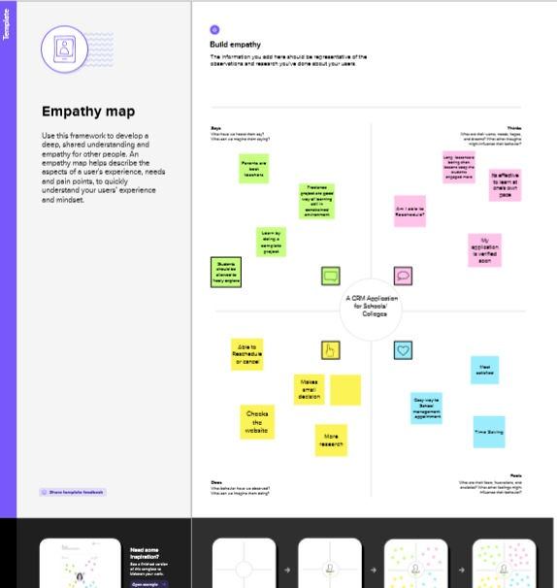

2.2 Ideation & Brainstorming Map

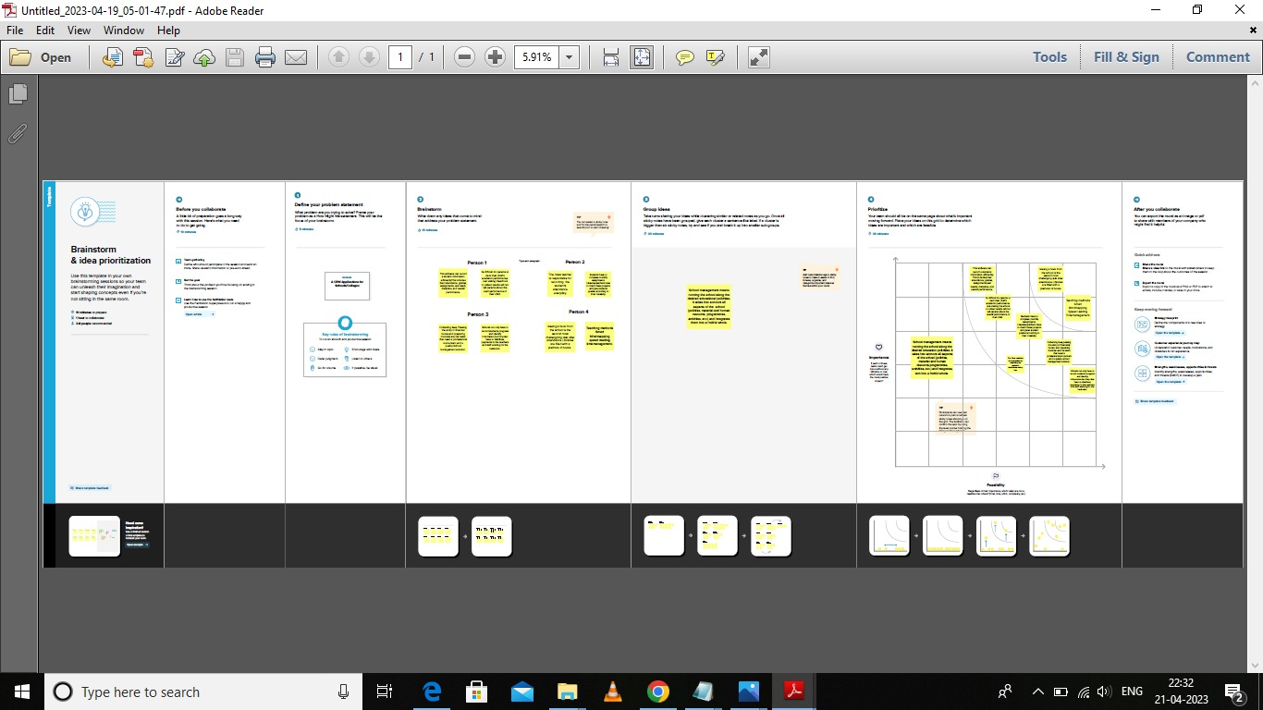

3 RESULT

3.1 Data Model:

|  |  |
| --- | --- |
| **Object Name** | **Fields in the Object** |
| **Obj1** | |  |  | | --- | --- | | **Field lable** | **Data type** | | School | Text | |
| **Obj2** | |  |  | | --- | --- | | **Filed Lable** | **Data type** | | Student | Text | |
| **Obj3** | |  |  | | --- | --- | | **Filed Lable** | **Data type** | | Parent | Text | |

3.2 Activity & Screenshot

Milestone 1-Salesforce:

Activitity-1

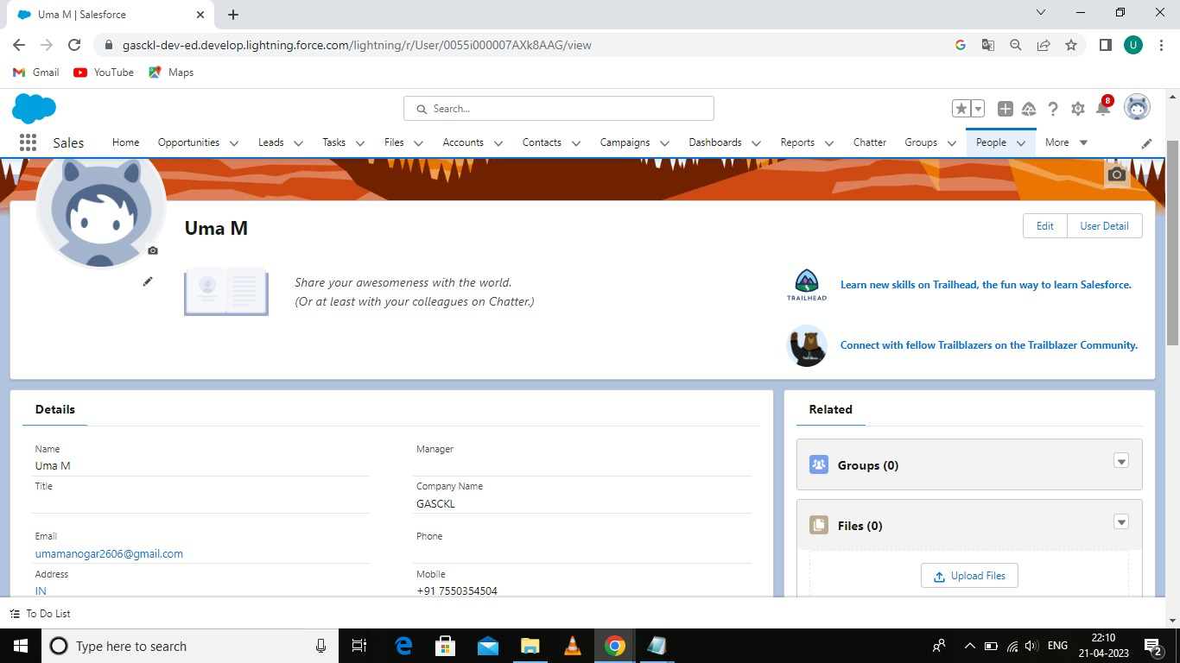

**Milestone 2 : Object**

**Activity :1**

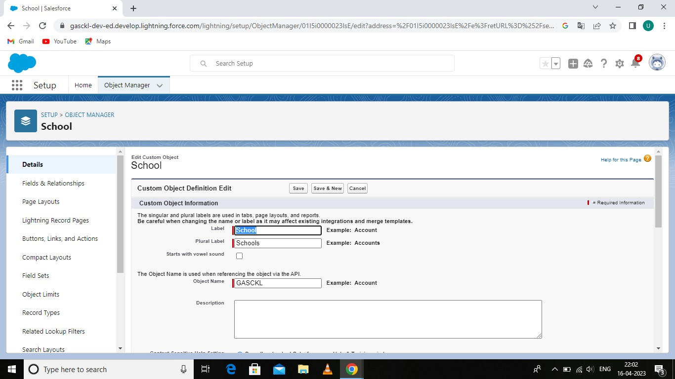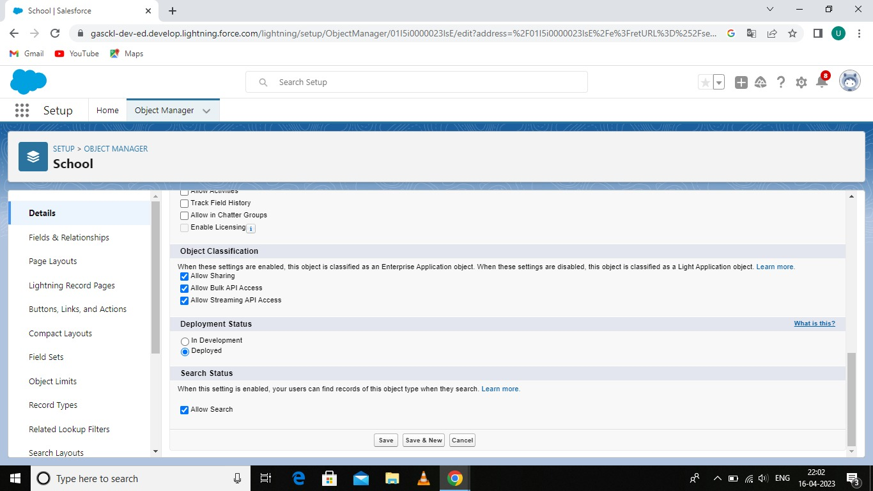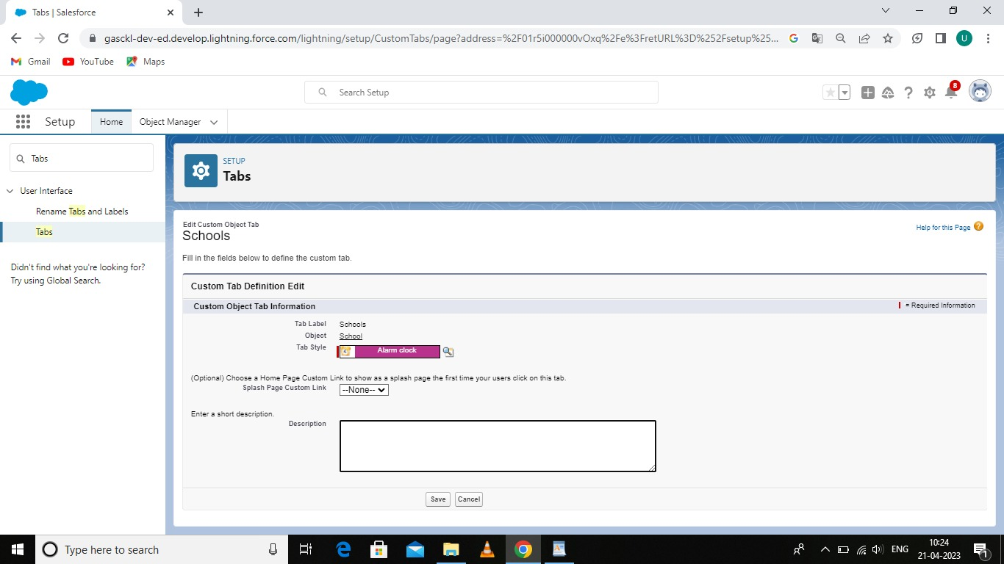

**Activity -2:Student Object**

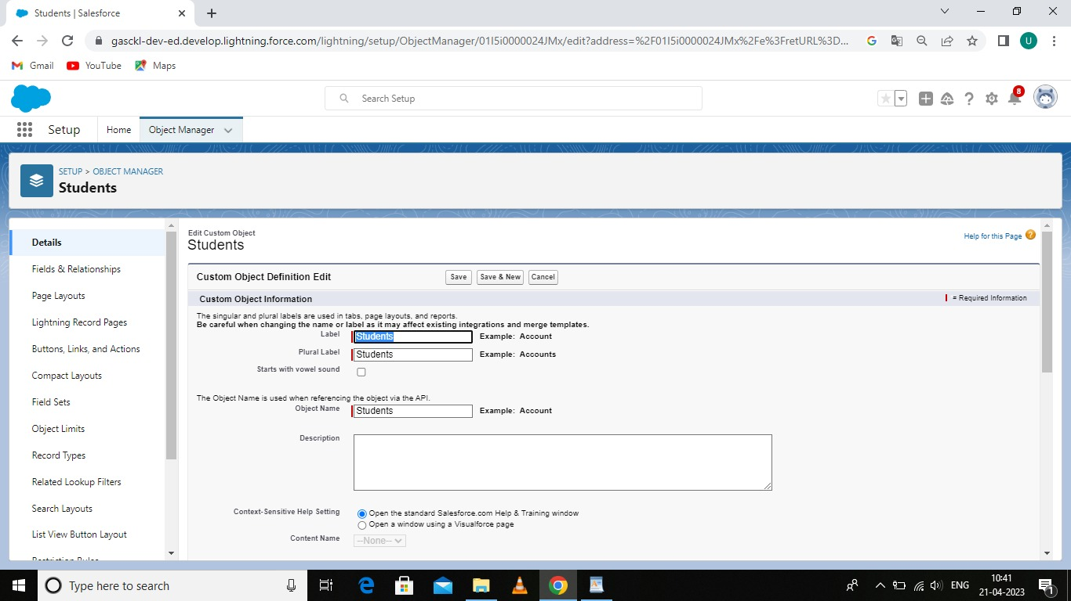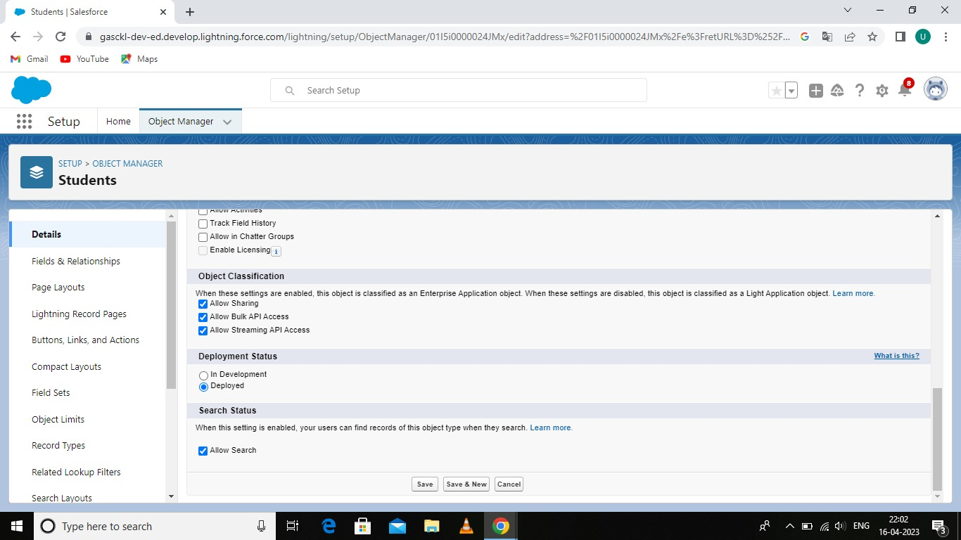

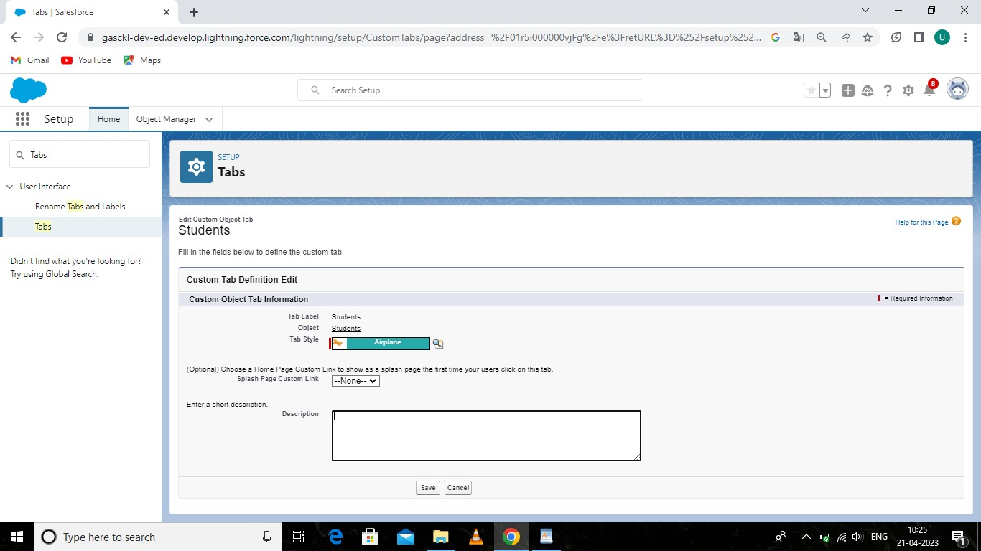

**Activity 3: Parent Object**

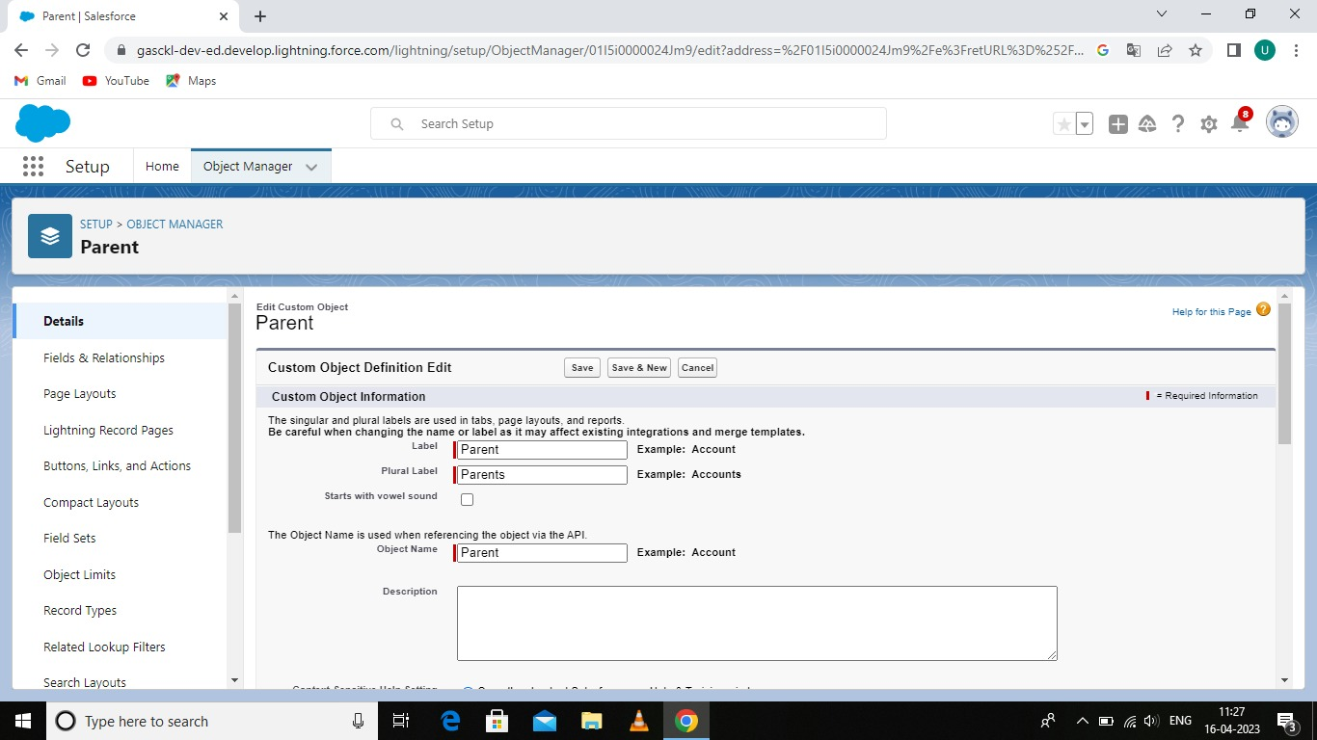

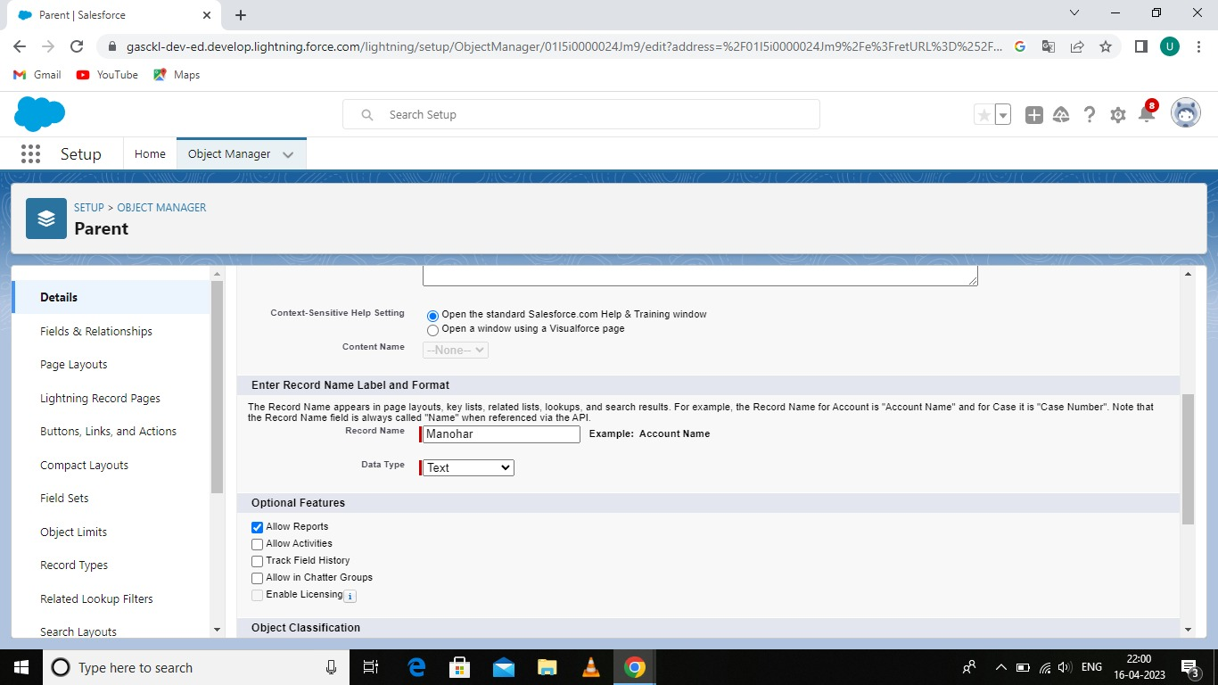

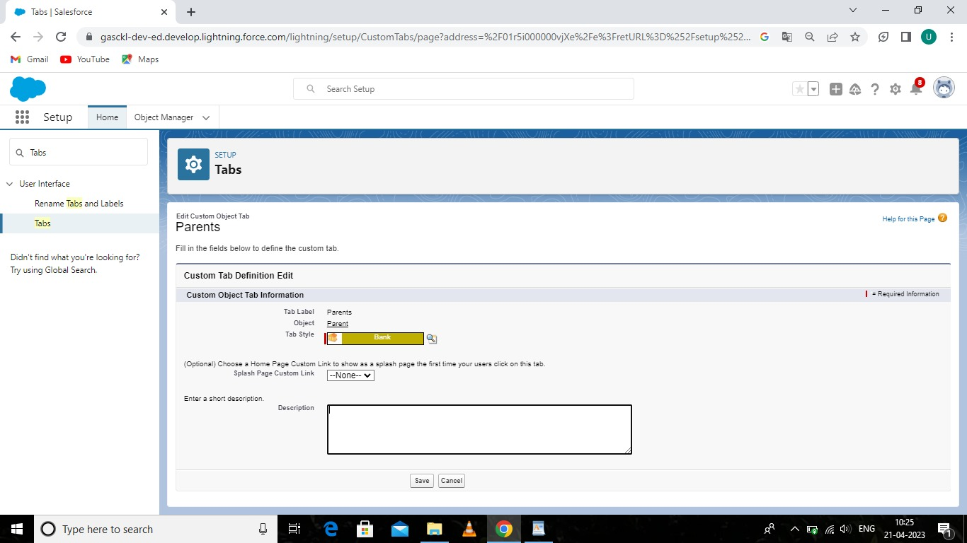

Milestone-3: Lightning App

Activity:

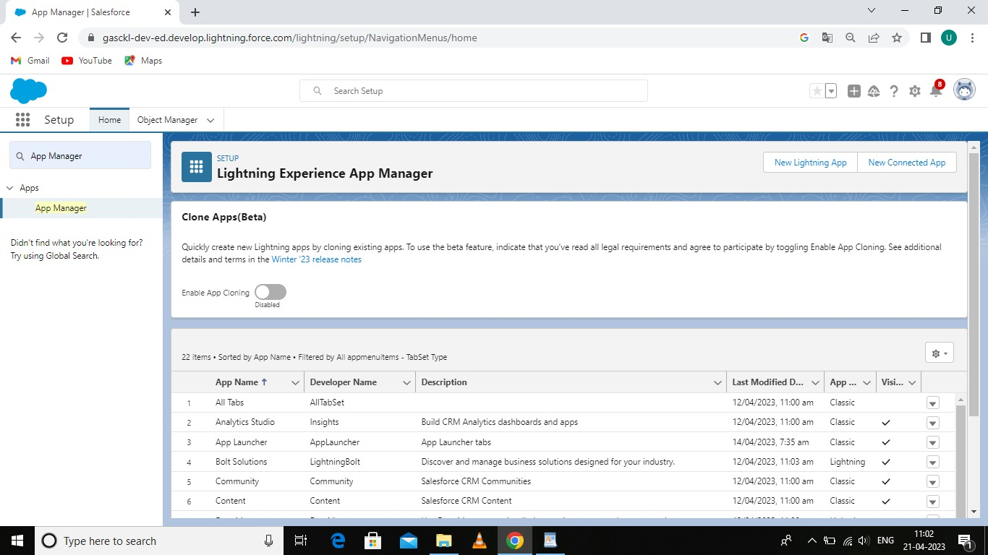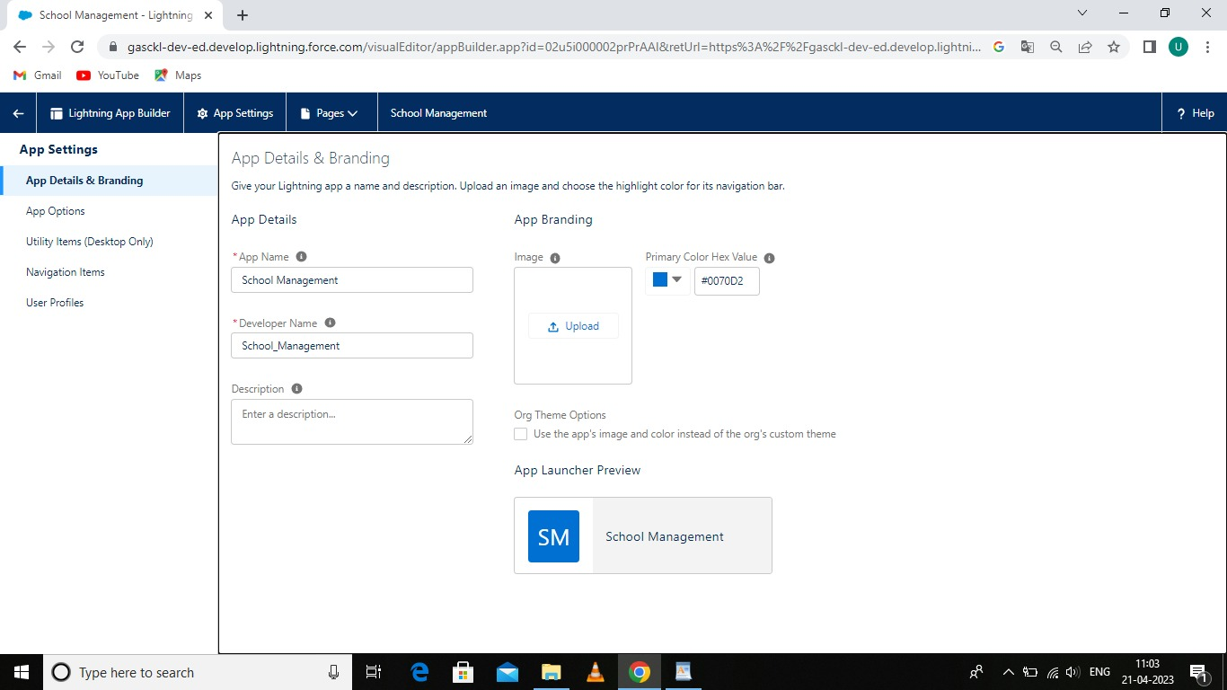

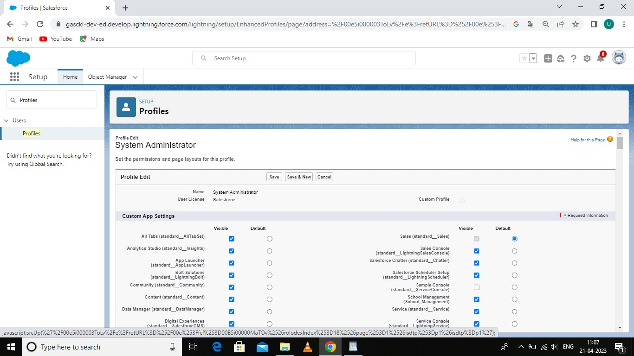

**Milestone-4: Fields and Relationship**

**Activity-1:School Object**

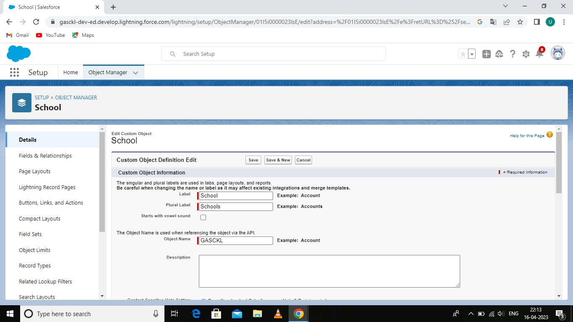

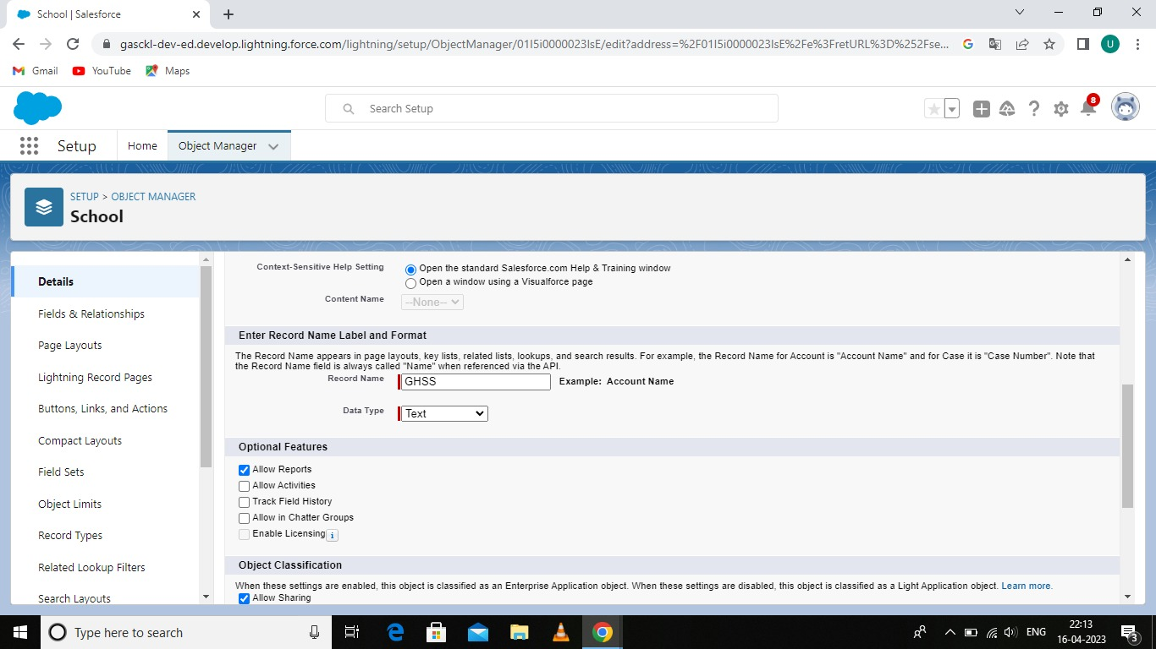

**Activity-2: Student object**

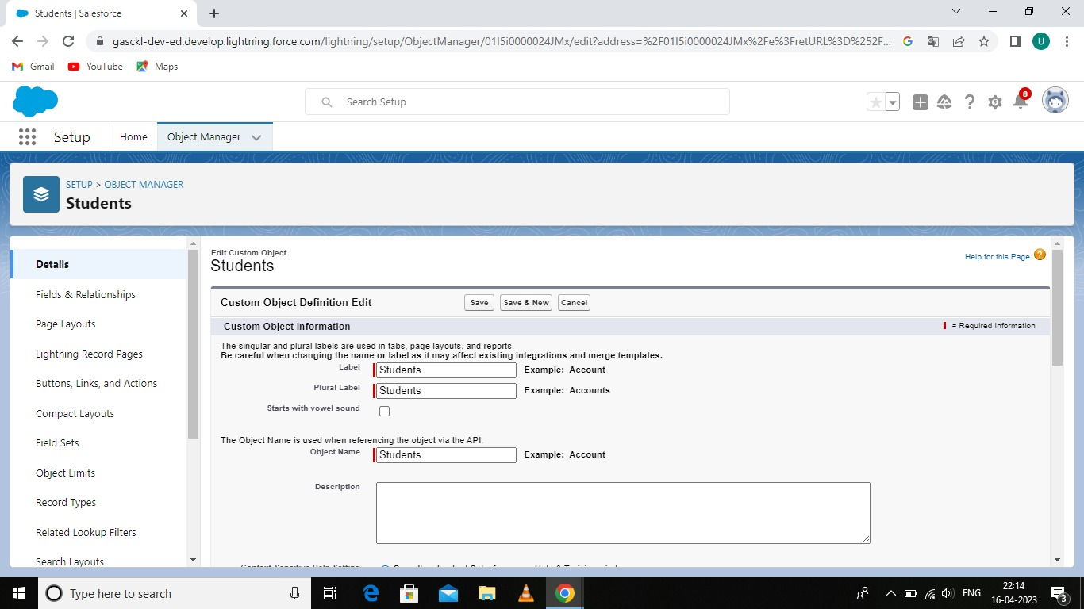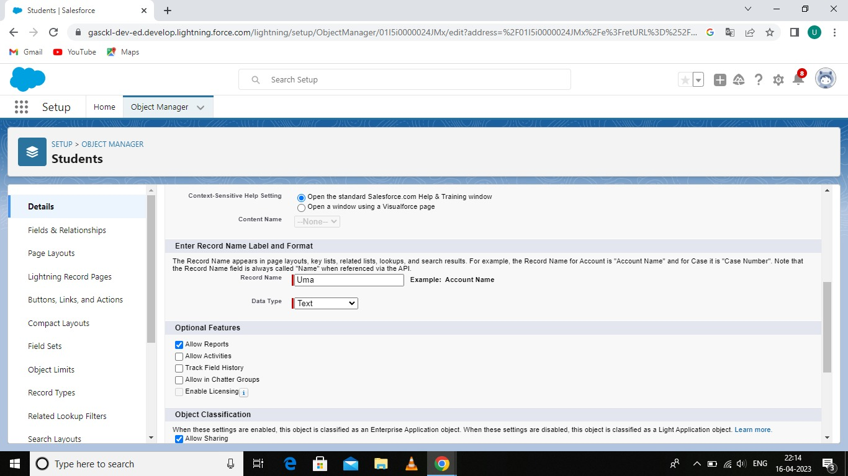

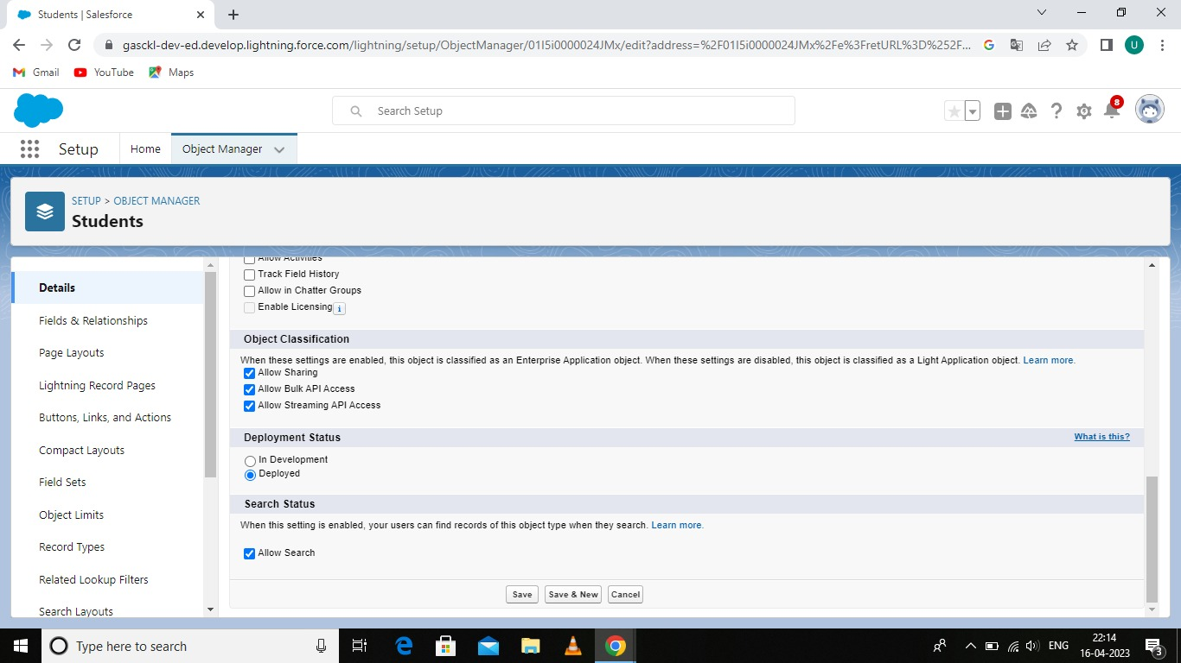

**Activity-3: Parent object**

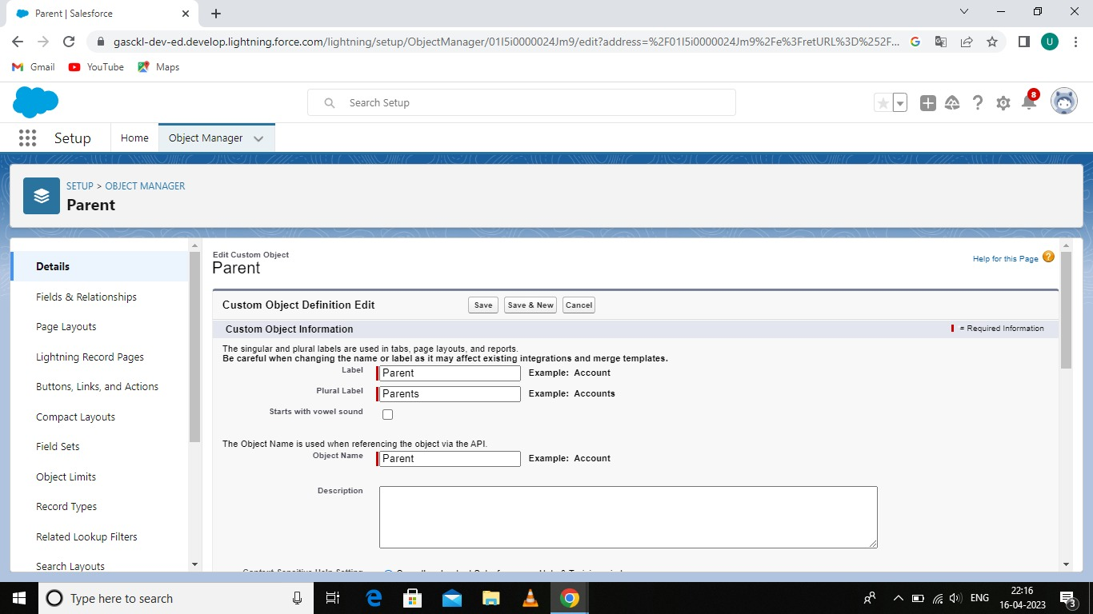

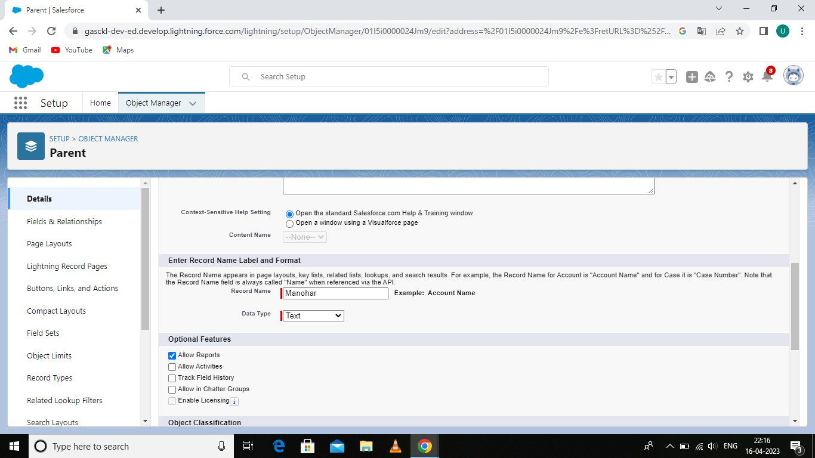

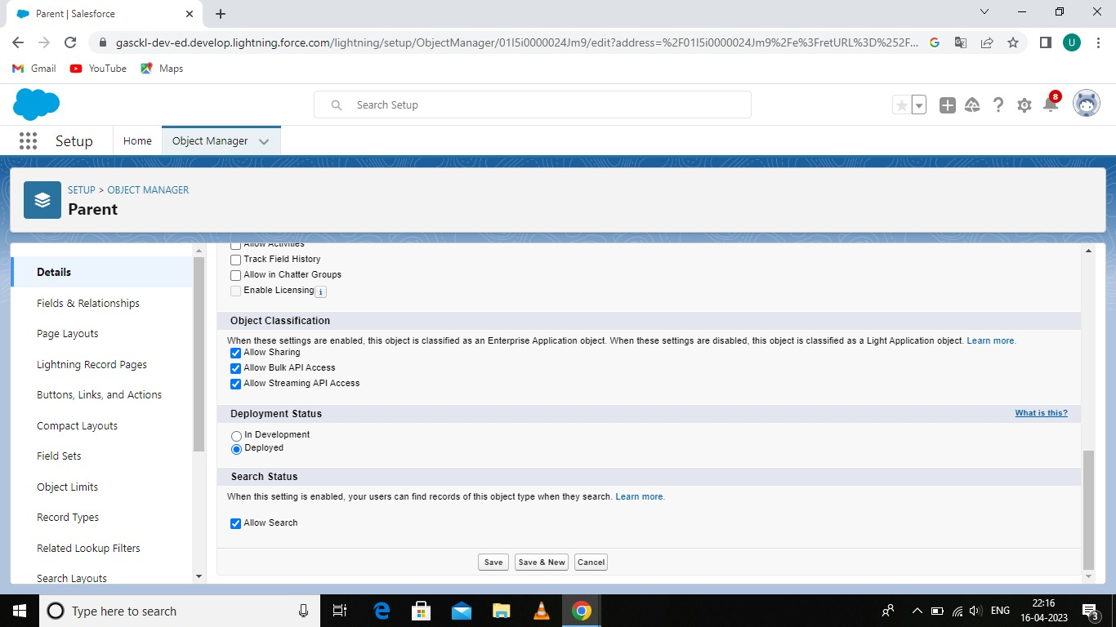

Milestone-5: Profile

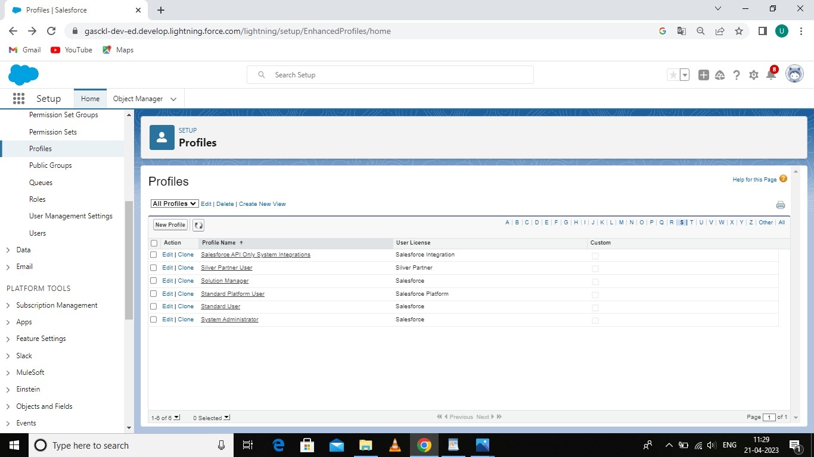

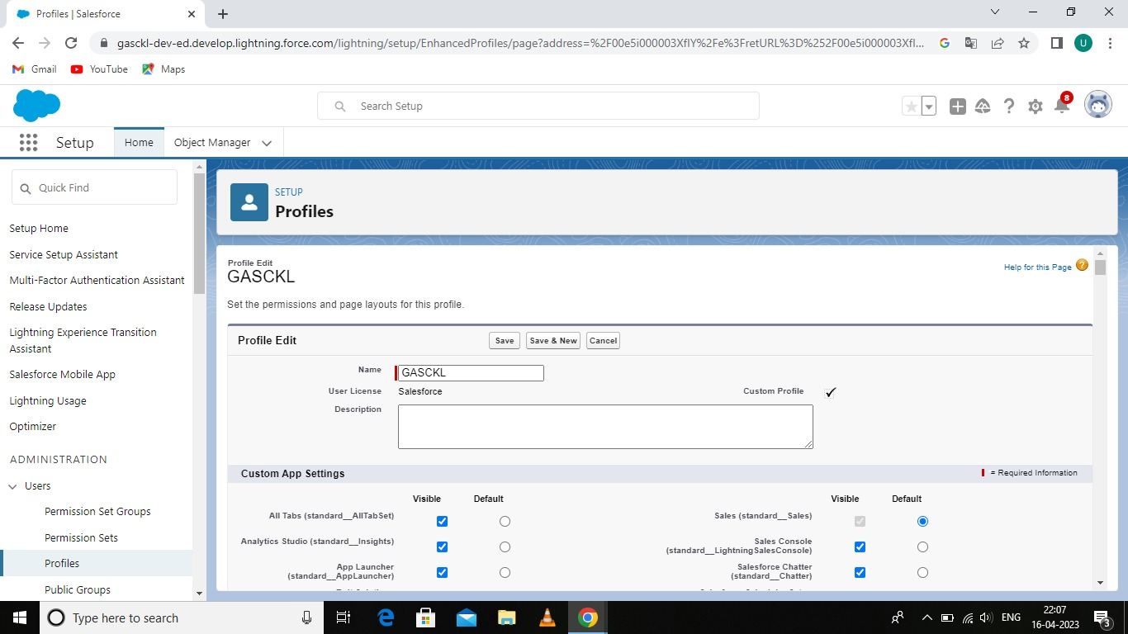

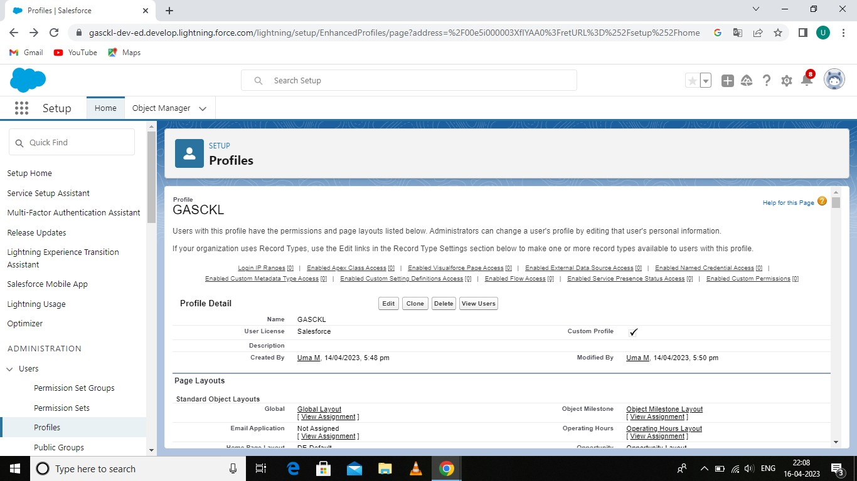

**Milestone-6: Users**

**Activity:**

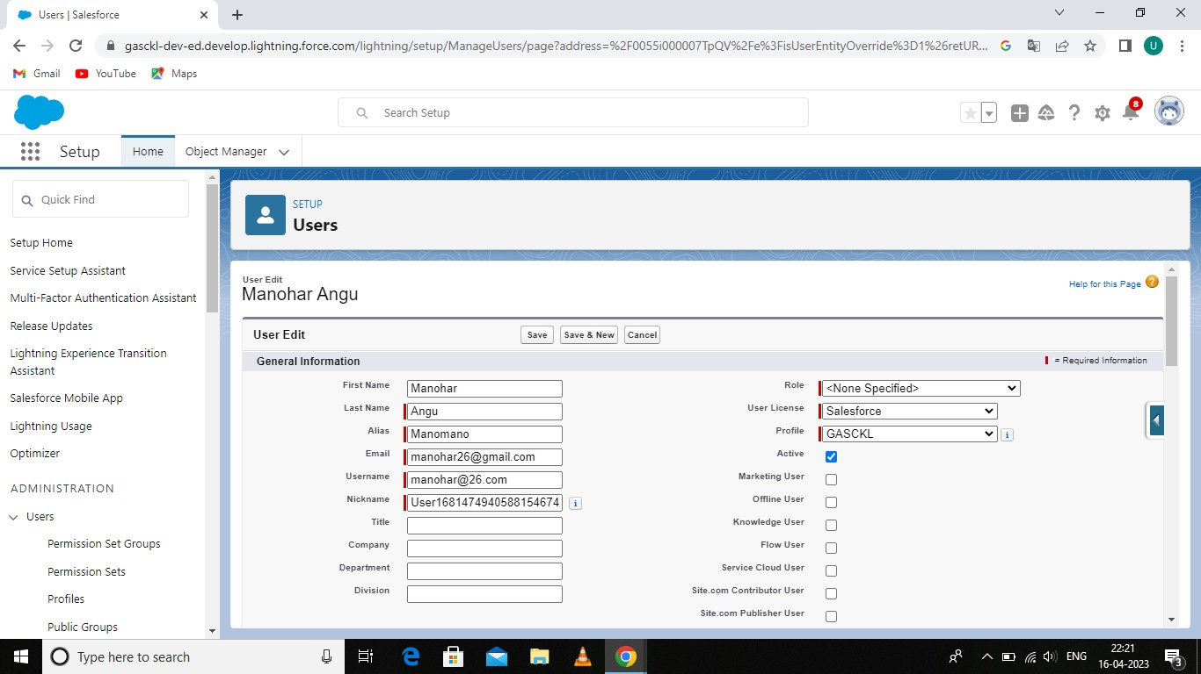

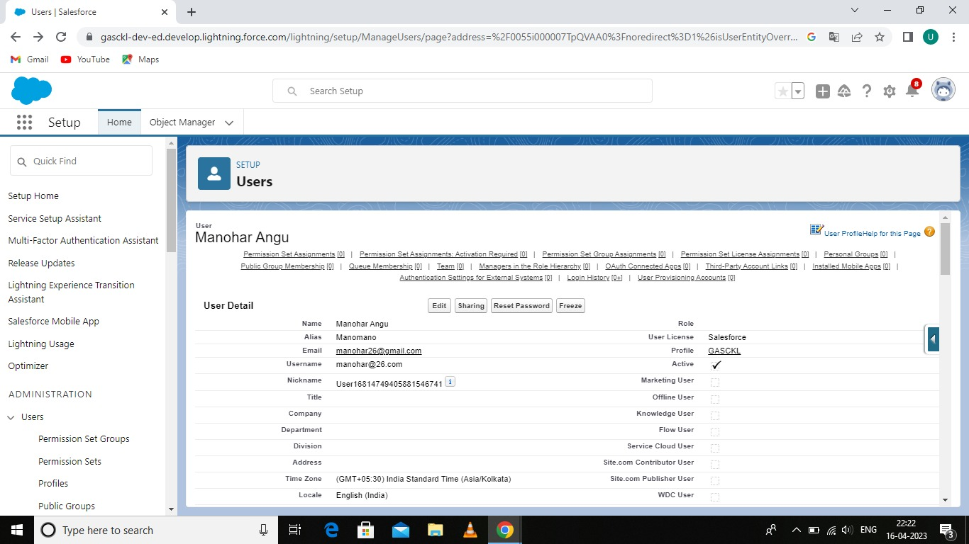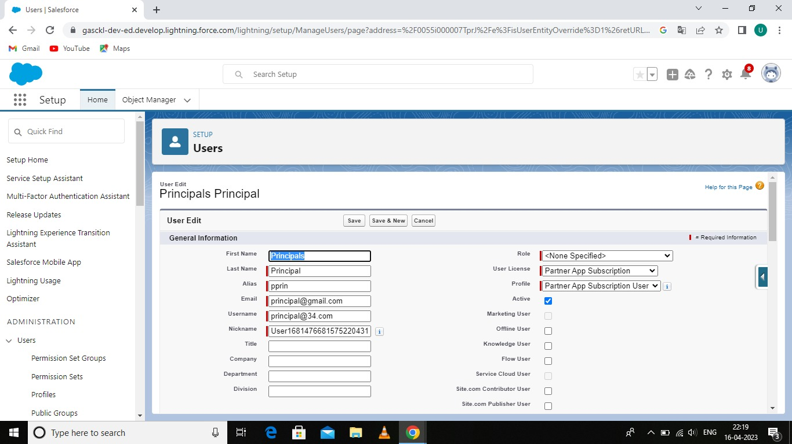

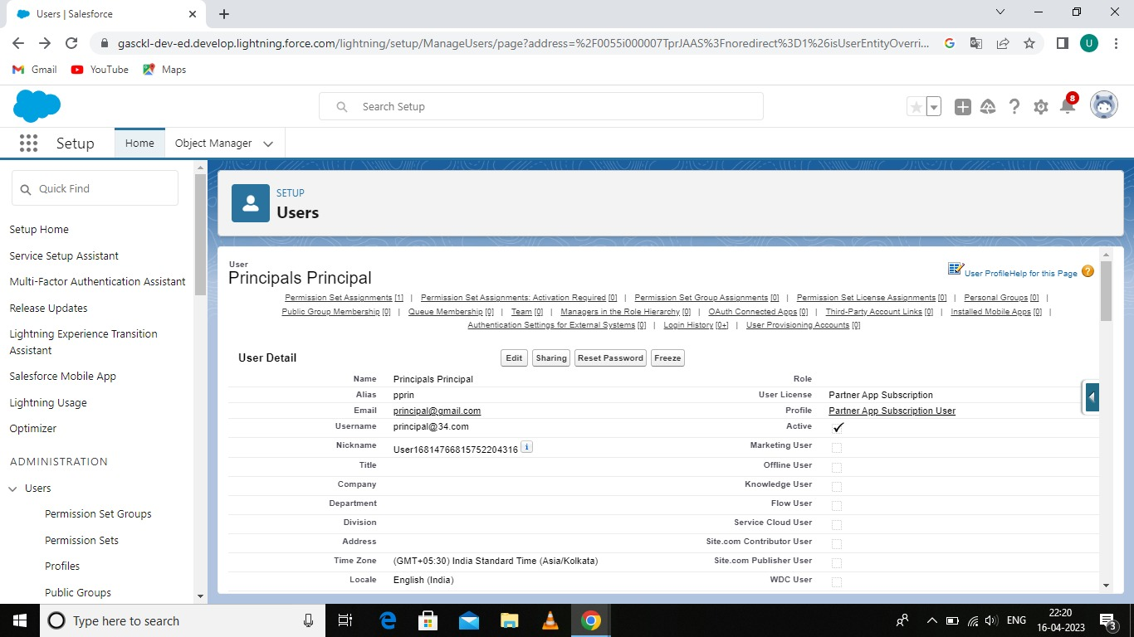

**Milestone-7: Permission sets**

**Activity-1:**

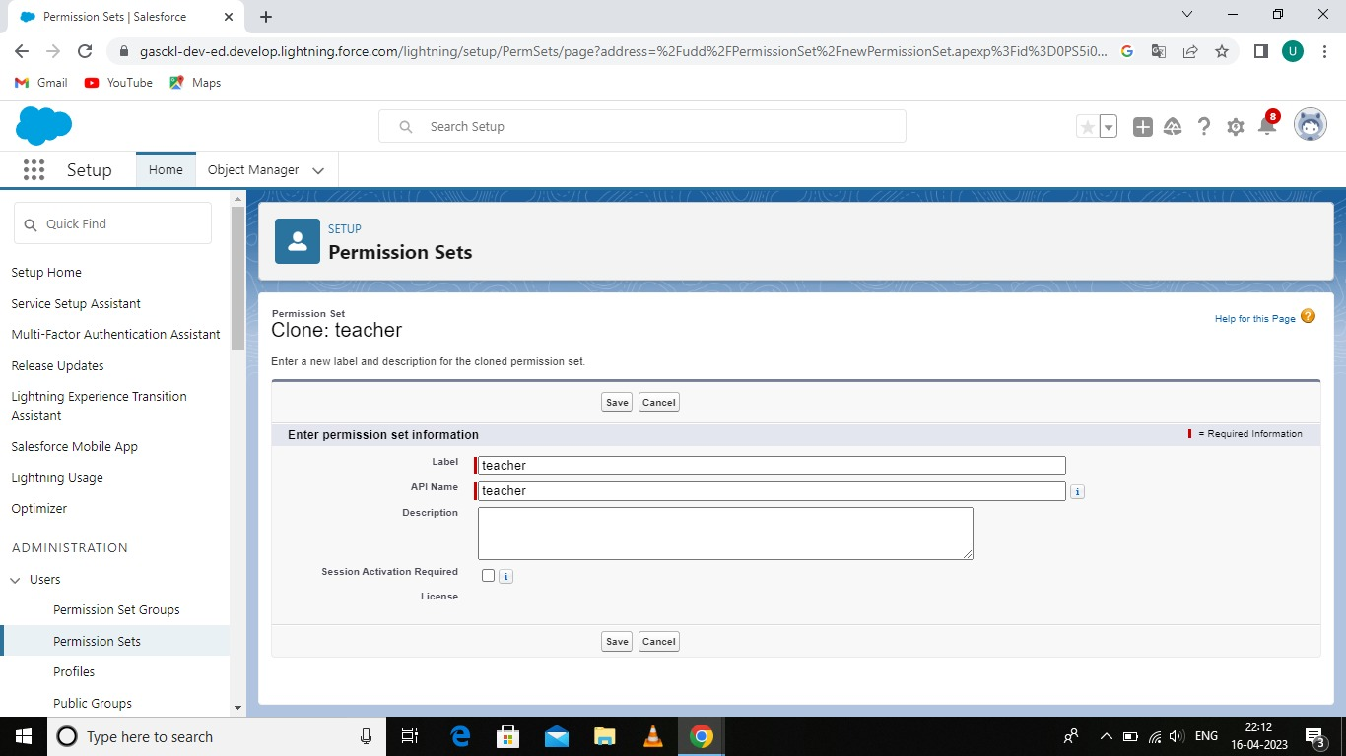

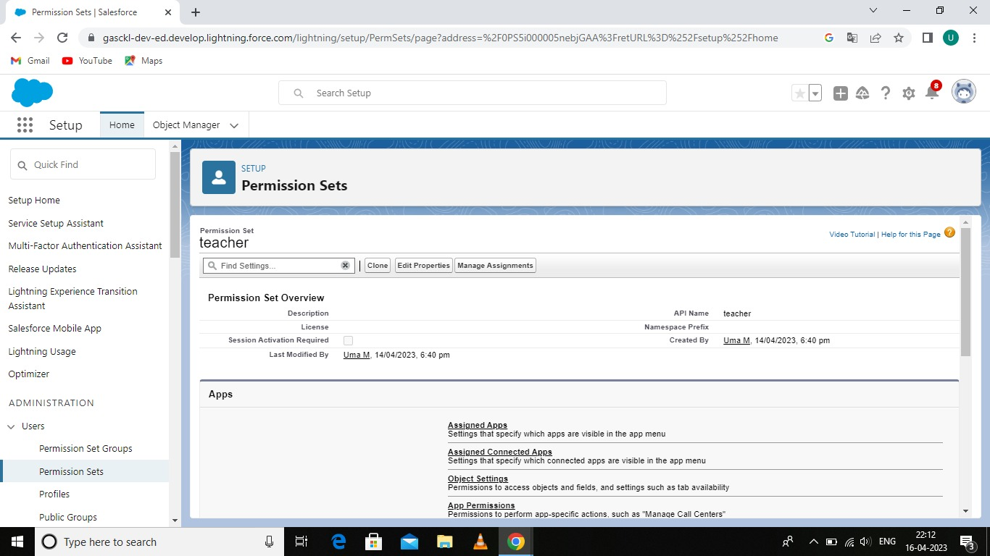

**Activity-2:**

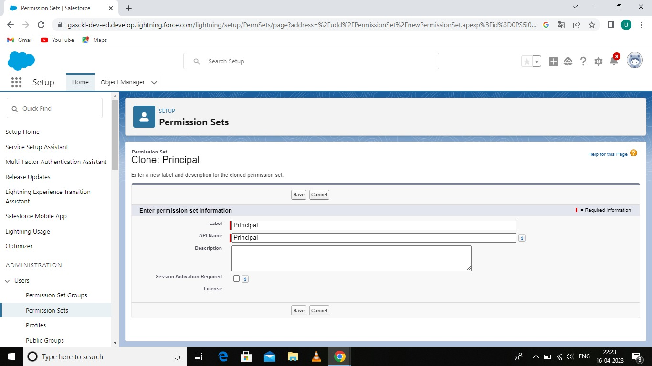

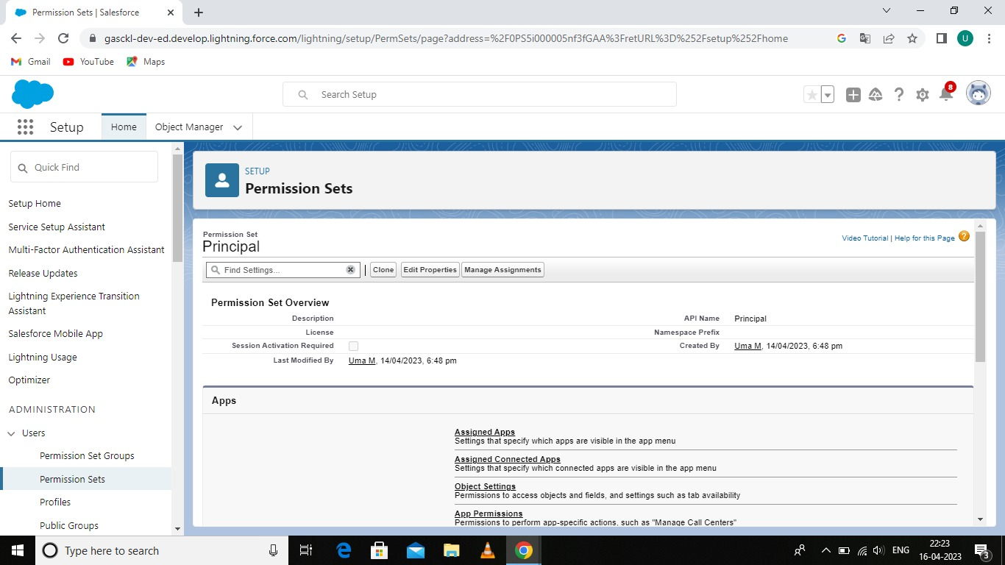

**Milestone-8: Reports**

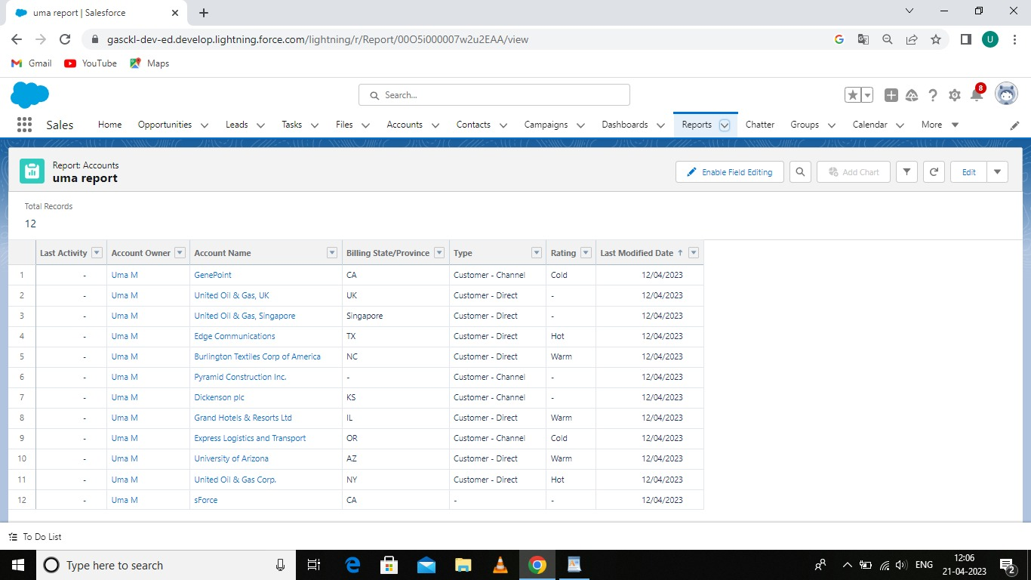

**4 Trailhead Profile Public URL**

Team Leader - <https://trailblazer.me/id/umamanogar2606>

Team Member 1 - <https://trailblazer.me/id/arjunsasi850>

Team Member 2 - <https://trailblazer.me/id/ddhanushvaithi>

Team Member 3 - <https://trailblazer.me/id/knithyashree2003>

**5 Advantages & Disadvantages:**

(i) Advantages:

* Advantages of Students Management System.

*Better Management of School Data.

*Improves overall Teachers.

*Provide deeper Insights to parents.

*This Instills sociable practices such as empathy, friendship, participation, assistance.

(ii) Disadvantages:

* School goverance is more complicated.

*Teachers and administrations are less accossible to parents.

*Problems with School discipline.

*A less improved School Climate.

6 APPLICATION

*The school management solution positively impact teachers, students, and administration and non-education staff.

* It can do by reducing burden of the repetitive tasks and producers by taking it over them and making communication and work simple through use of the intutive features.

7 CONCLUSION

*In this project, I have explained about the topic 'A CRM Application for School/College' by providing full details on it.

*This project also emphasizes on main ideas related to the topic.

*I wish this project will be a useful and the knowledgeable one.

*At last I would like to share my experience while doingthis project.

8 FUTURE SCOPE

*Developing the goals and policies for school activities.Providing direction to the developmental programmes designed to achieve the goals and purpose. Planning and implementing programmes of school organization. Procuring and managing resource men and material necessary for educational process.